**Contact Management Application**

manages contact directory.

Functions - Add Contact, Delete Contact, Update Contact.

Technology used - ASP.NET6.0, C#, EF, MVC Architecture, MSSQL

Database Setup and View

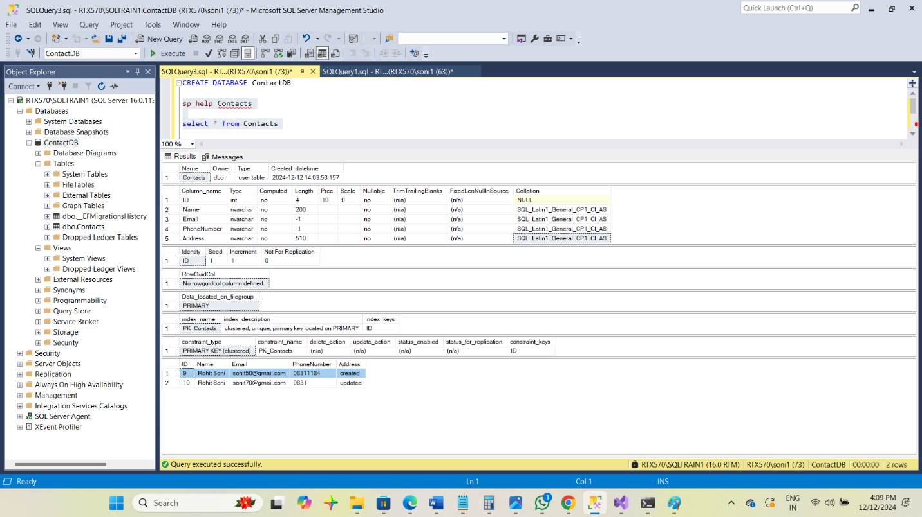

ADD or Create New Contact

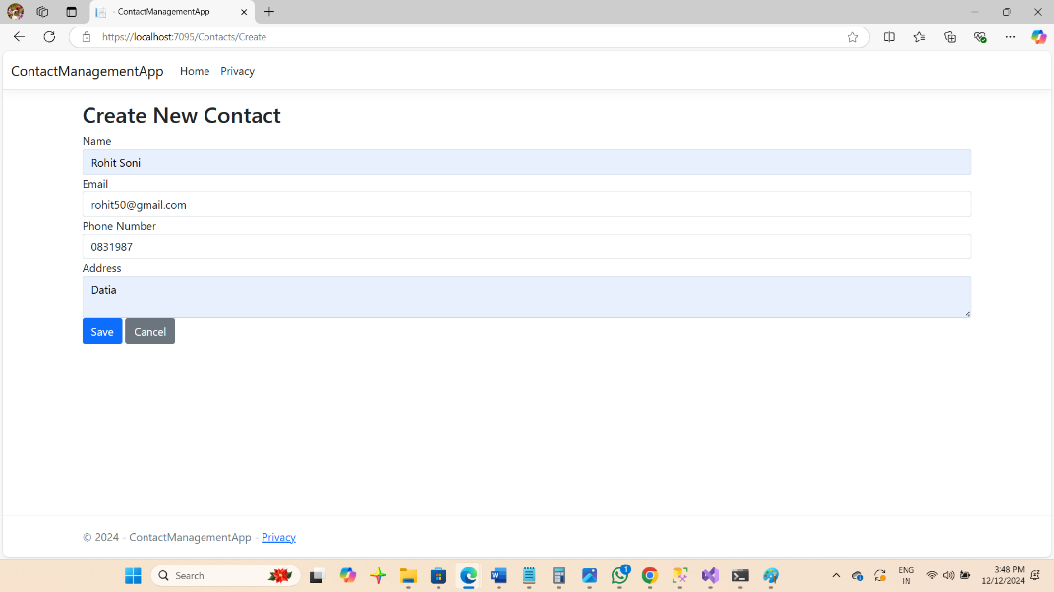

Update Contact

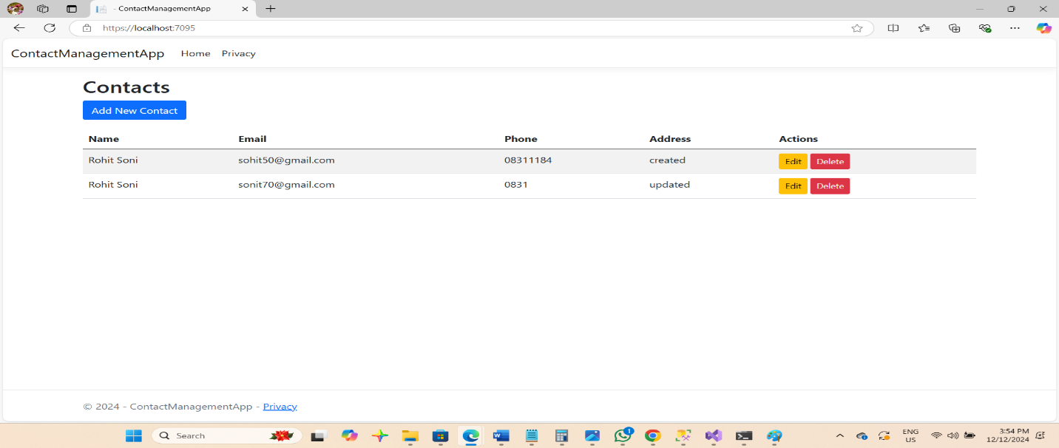

Delete Contact

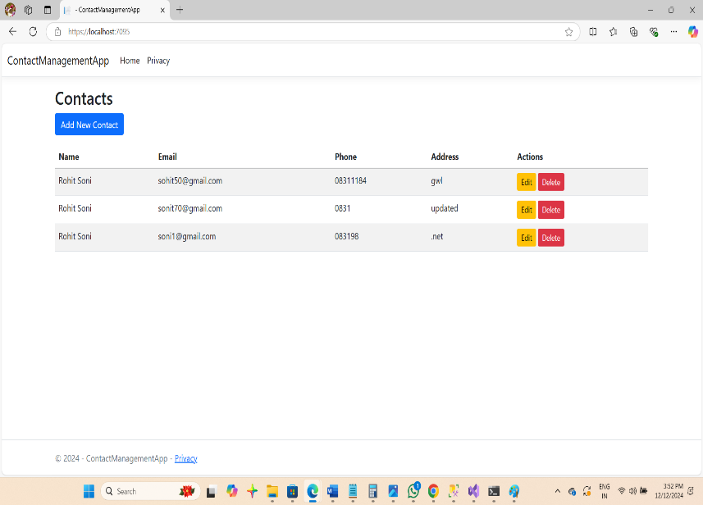 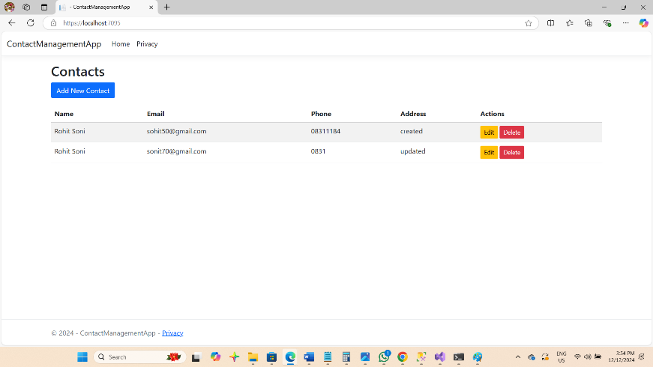

Thanks

Rohit Soni